EMG Final Analysis

Here we plan on looking at the key questions that are going to be used for the abstract submission. Subject 1_004, 2_008, 2_022, and 2_027 were not accurate. There were very large values for the peak absolute percentage. So, I removed those subject cases. Some key notes that we are looking to include:

1. General Interpretation: The more rightward the curve is shifted the more time you spend at a maximum voluntary contraction/EMG amplitudes. Shifted to the right is more effort spent and shifted to the left is less effort spent.
2. Showcase the EMG data for rampart versus lead in averages or one case that showcases major differences.
3. Stratify the EMG Stats by rampart versus lead and create tables and graphs for it.

# Stratify APDF Data for Rampart Versus Lead

* 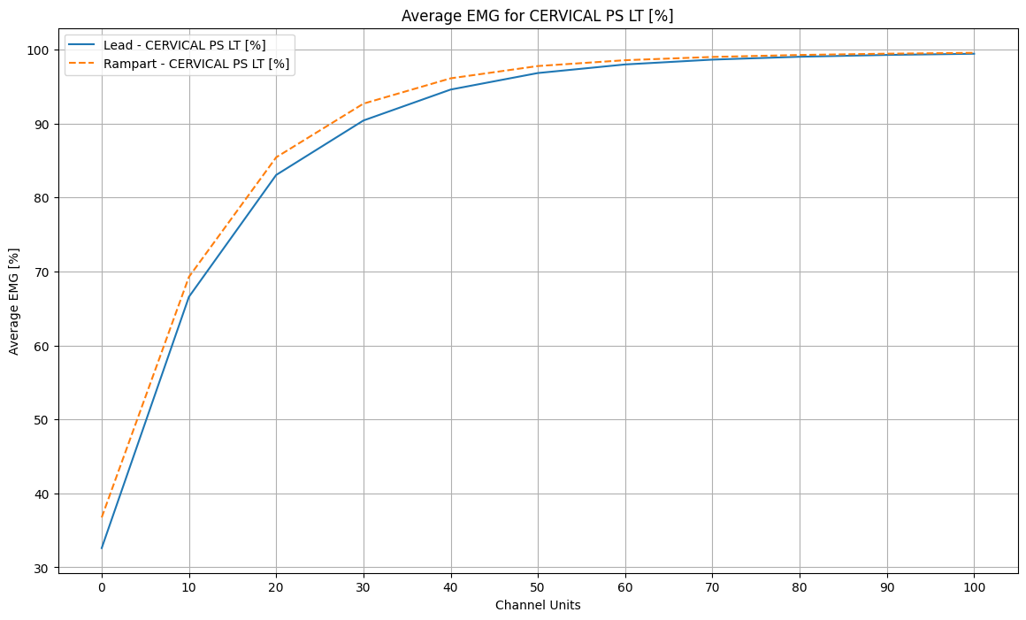
* 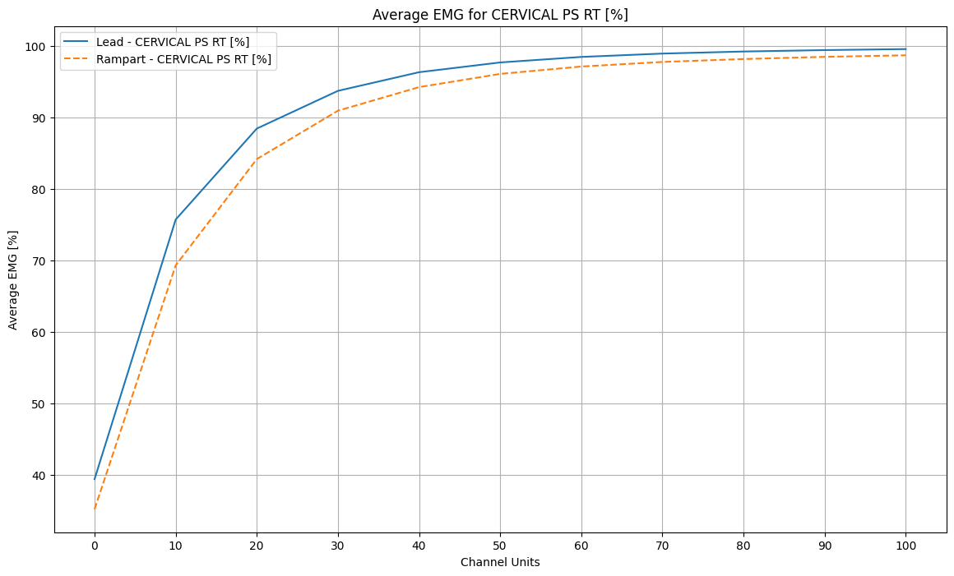
* 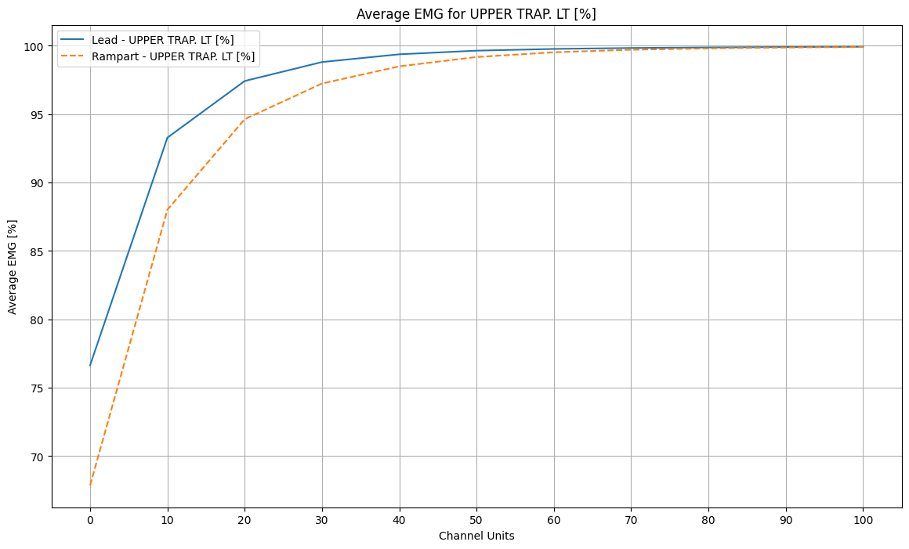
* 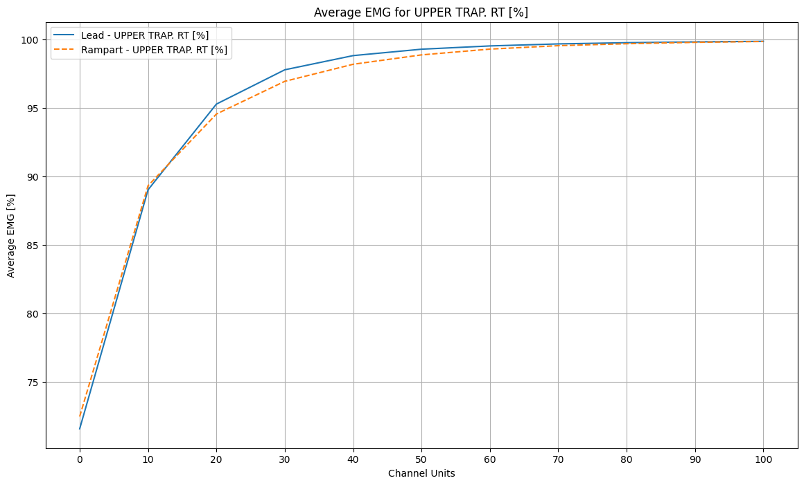
* 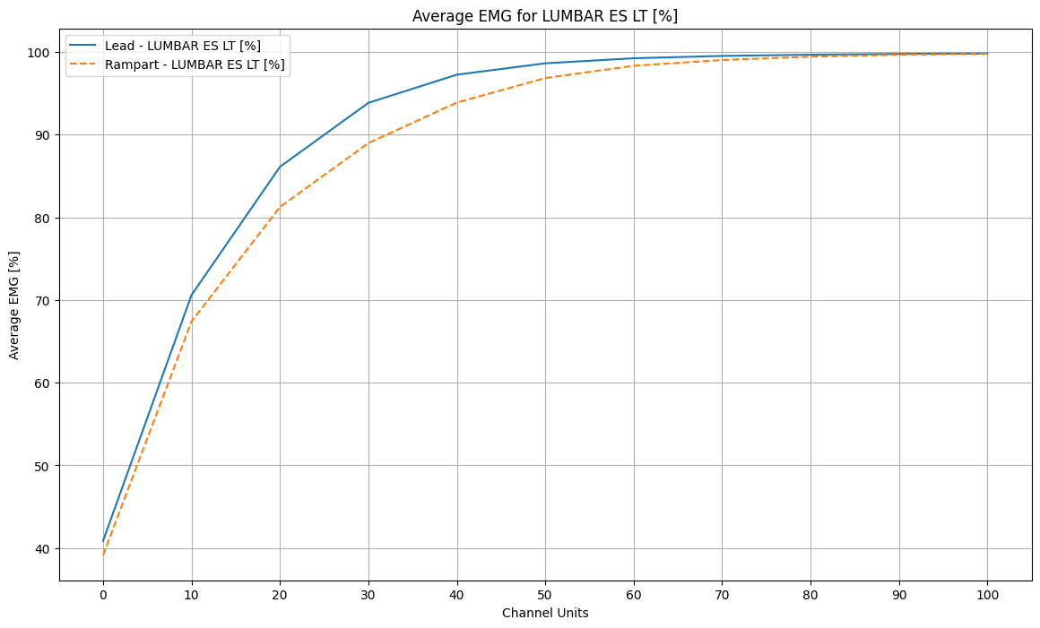
* 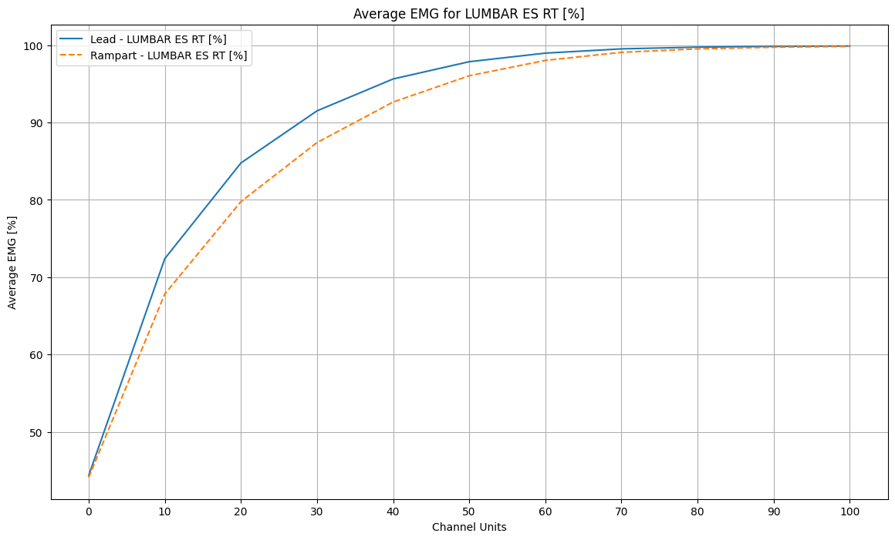
* 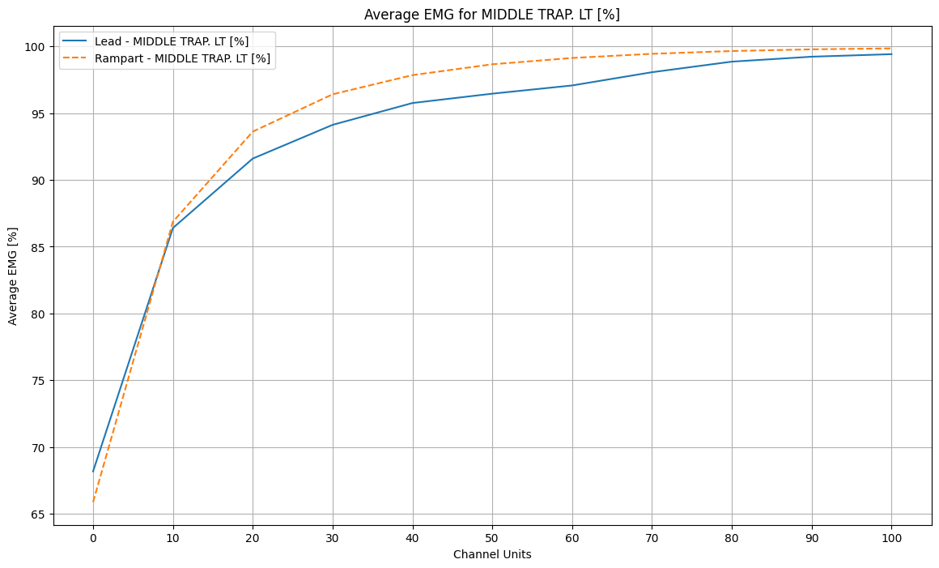
* 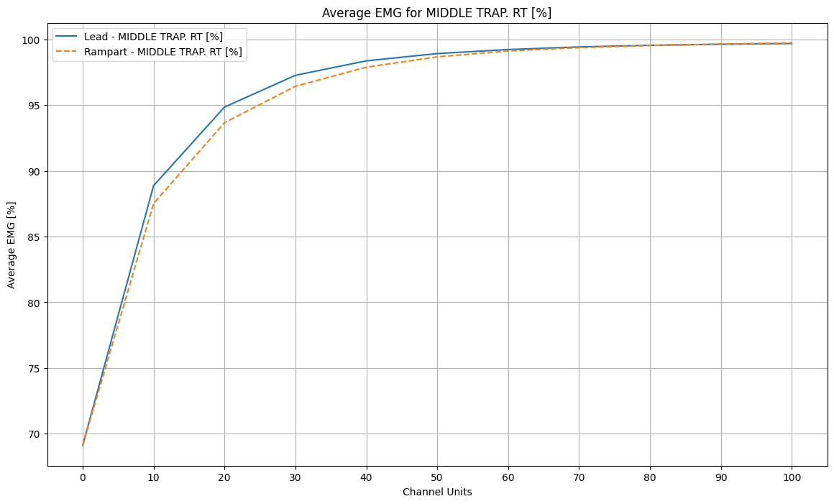
* Generally, the rampart was more rightward-shifted for most of the data, but it wasn’t always that way for each muscle group location.
* Here is a good subject example for the rampart being typically more rightward-shifted:
  + 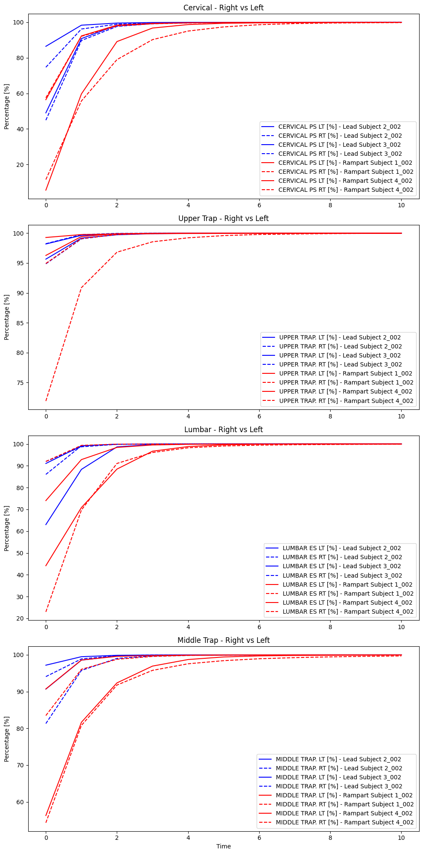

# Stratify EMG Stats by Rampart Versus Lead

* 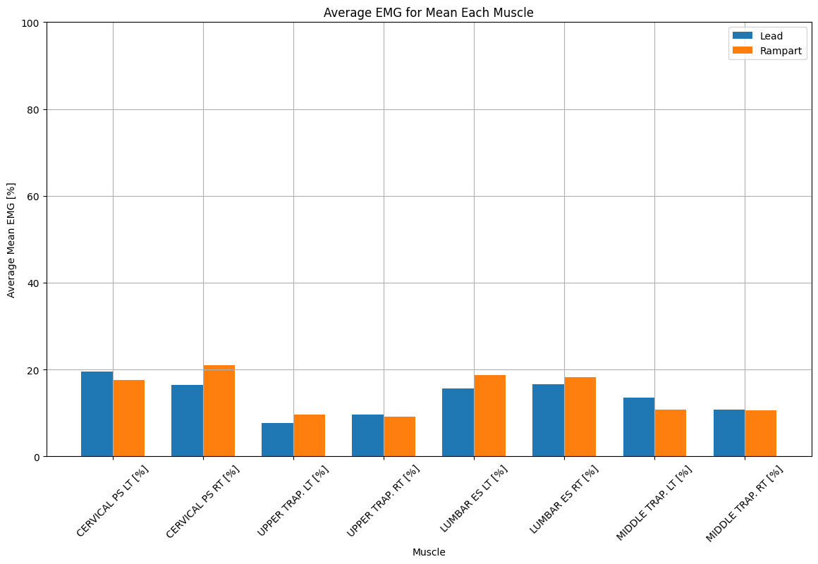
* 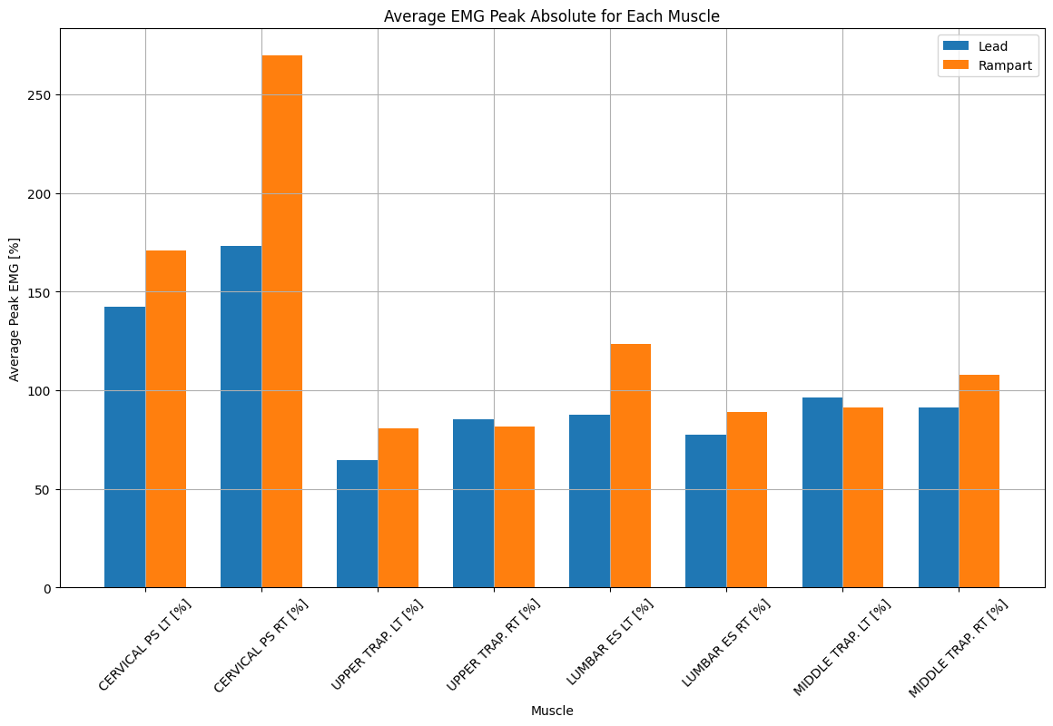
* 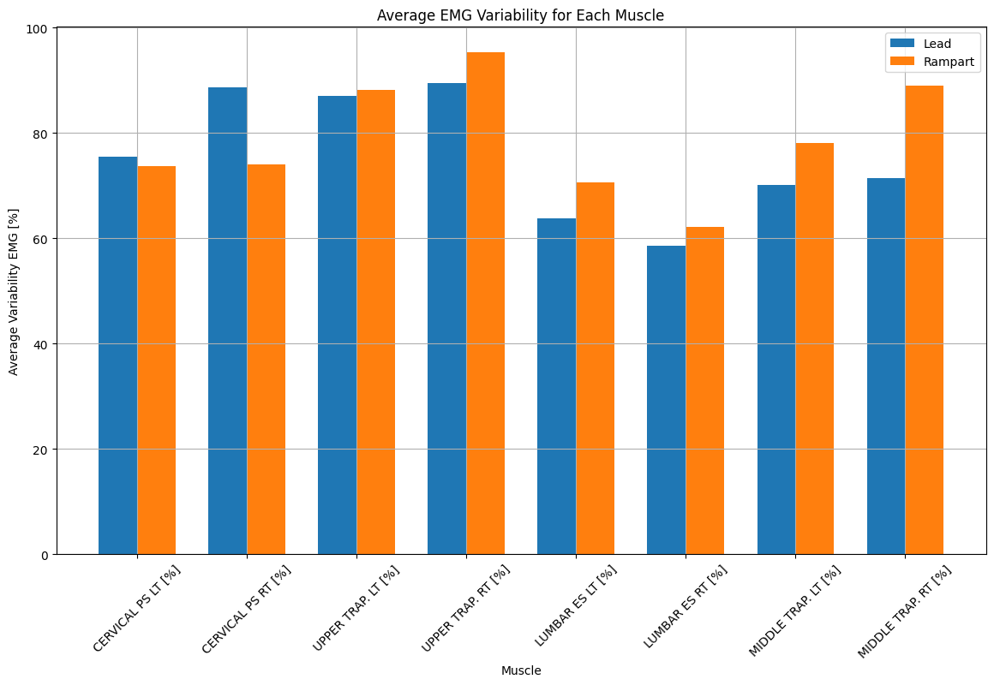

# Table of Lead and Rampart Averages

* Lead Averages (Note: Time_00 = 0 channel units, Time_01 = 1 channel units, and so on)
  + 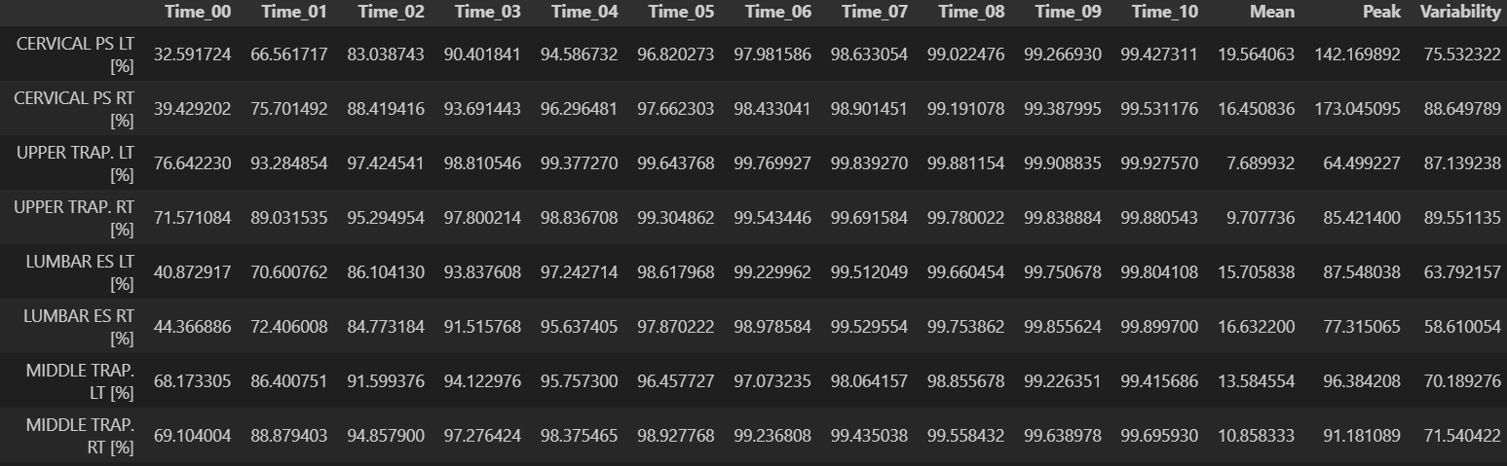
* Rampart Averages (Note: Time_00 = 0 channel units, Time_01 = 1 channel units, and so on)
  + 